# chandigarh-university-seal

# WORKSHEET-2.3

# Student’s Name : ARNAB DEB

# UID: 20BCS7438

# SECTION/GROUP: 20CSE10/B

## Screenshot 1-

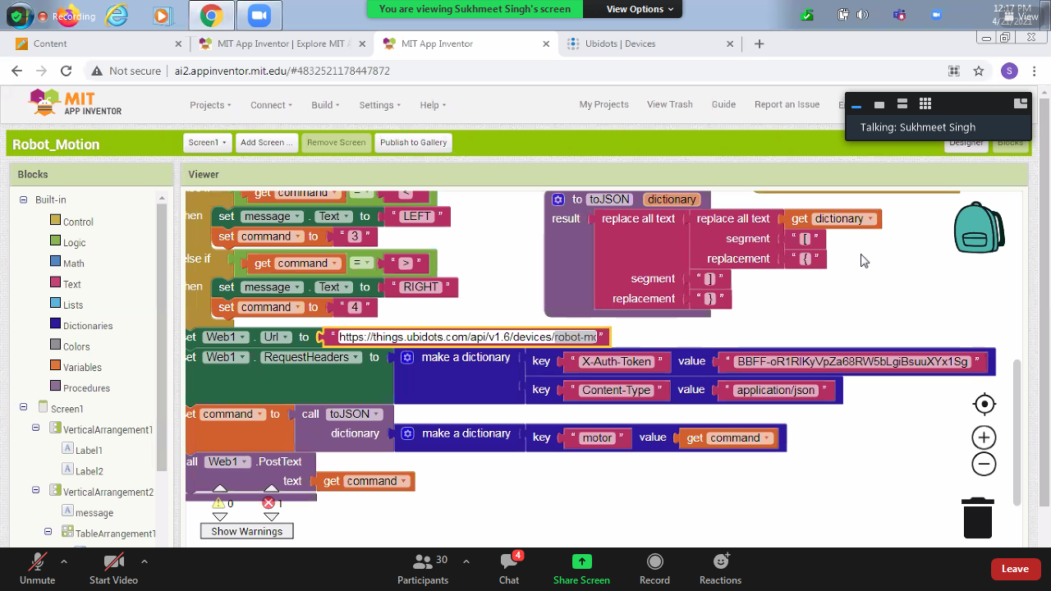

## Screenshot 2-



 